<https://youtu.be/bDxclRhDb-o>

RDF (Resource Description Framework) provides a standardized universal model for representing data and its meaning

* Support hybrid, varied and changing data models with ease (facilità)
* Easy to represent any change in data or schema
* Interoperable (scambio e utilizzo di informazioni) and composable

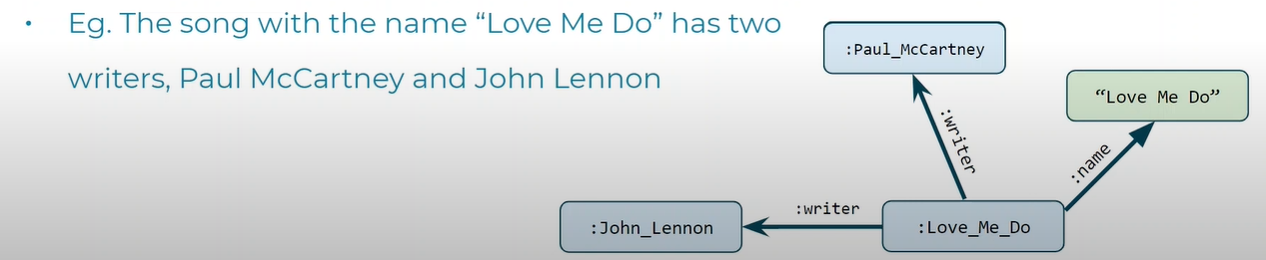

RDF express relationship in the wave we usually talk:

**subject**---(*predicate*)--->**object**

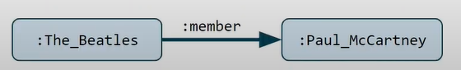

**CLASS:**

* type of thing (band or artist)
* made up of a set of **individuals** (The Beatles or John Lennon). Individuals are also called instances or objects

A class or an individual can be the subject or the object in a RDF triple

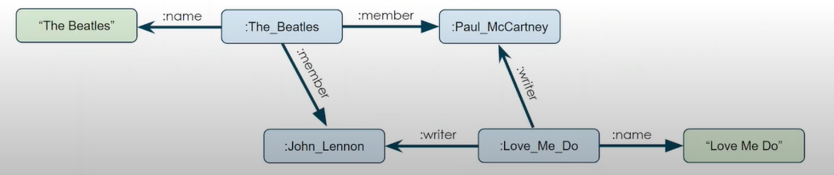

**subject**---(*predicate*)--->**object**

*PREDICATE*

* **Object property**: if the predicate describes a relationship between two objects (classes or individuals)

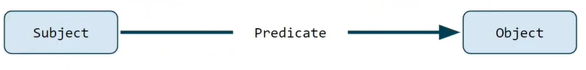

* **Data property**: if the predicate provides data (number, date, string…) about an object. Describe an attribute

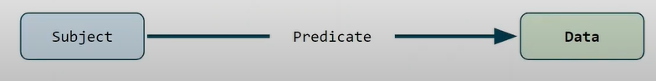

In a graph the points representing objects or data are called **nodes** while the predicates that connect them are called **edges**

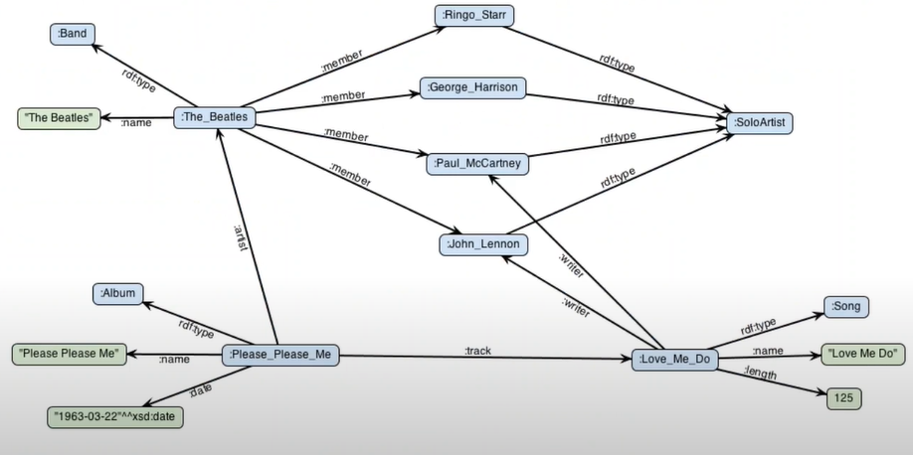

On green there are data types values (string, number and dates)

**rdf:type** special built-in edge identifier. Link entities to special nodes that represent classes

**Recap**:

* two kind of objects:
  + classes: are set of collections, types of objects, kinds of things
  + individual/instances: what a class groups together
* two kind of property:
  + object property: relationship between two things
  + datatype properties: attributes of one thing
* classes and individuals are called nodes
* properties are called edges
* in RDF triples:
  + classes and individuals are the subjects or objects
  + properties are predicates
* a set of RDF triples is called an RDF graph

**IRI**: (Internationalized Resource Identifier) nodes or edges with an unique identifier. Usually resemble urls. Unambiguously refer to something. Can also be used to identify predicates

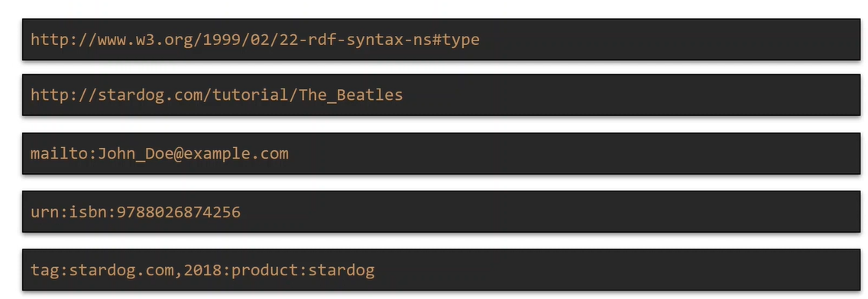

Every URL is also a URI, but not vice versa

**Literal**: nodes representing values like number and dates

**Blank node**: nodes without an explicit identifier

**IRI** are long and not human friendly we short them using a prefix

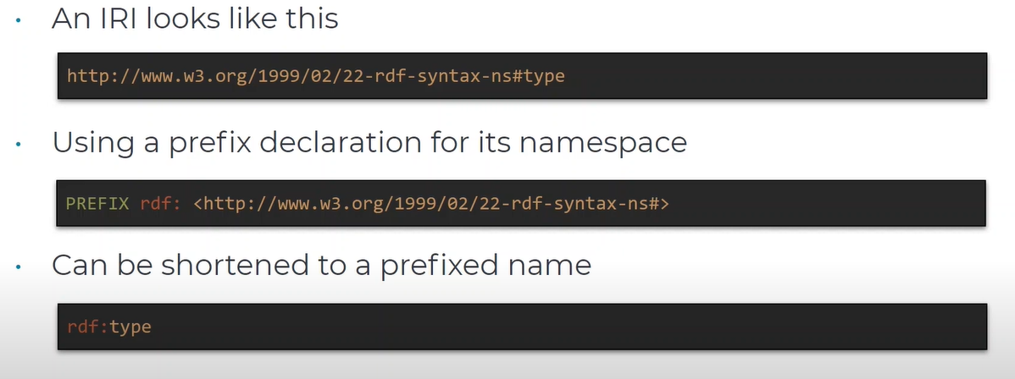

so *rdf:type* represent the iri that is the concatenation of that namespace with the local name *type*

**Literal** are read in quotes (“ “) followed by their datatype IRI

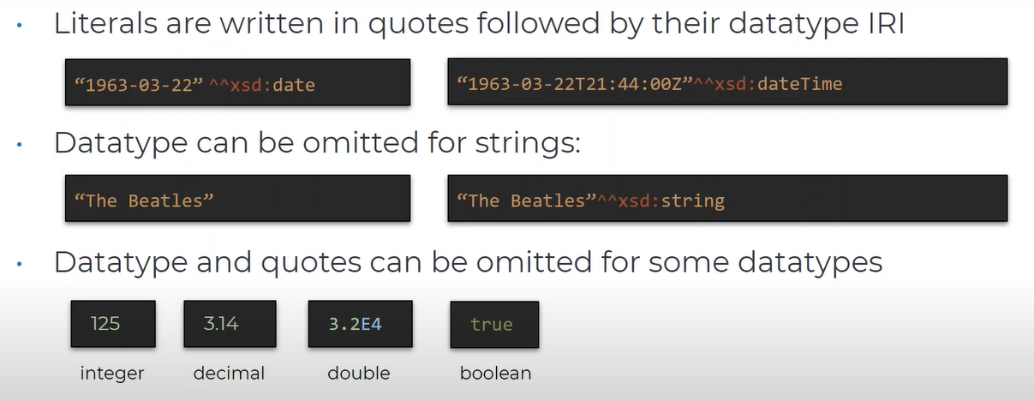

xsd: prefix denotes the namespace for the xml schema data types

datatype can be omitted for strings

for some datatype (like integral, decimal, double and boolean) you can omit the quotes

|  | **SUBJECT** | **PREDICATE** | **OBJECT** |
| --- | --- | --- | --- |
| Class or individual | yes | no | yes |
| IRI | yes | yes | yes |
| Literal | no | no | yes |
| Blank node | yes | no | yes |